Step 7
Inventories
I never came across inventory until I heard about it in my previous unit, which was a very basic concept. My understanding of inventories is that businesses store goods and materials to support the continuation of their sale operations. I learnt that inventories are an essential part of a company's activities as holding inventories can have some significant benefits for a company. This includes meeting market demand for products, cheaper for the company to buy in bulk than a small amount, managing transit cost, changes in price and many other benefits the list is very long. However, holding inventories can also come with some negative aspects as everything it has its pros and cons. Some of the negative aspects of holding inventories are that the business' capital can be tied up when purchasing inventories in large amount; the value and quality of products that can be reduced if they kept for very long in stock; the changing in price due to unpredicted circumstances; storing costs etc. the lists are also long. I believe that many businesses would try to balance the advantages and disadvantages depends on the companies' strategies and needs. I also learnt not all companies have inventories, especially for companies that involve in selling services.
As my company is involved in designing, manufacturing, selling and marketing, I do have inventories in my balance sheet. Through my reading chapter 4 and watching Maria's video, I learnt that when a company has inventories, there will be a figure called "cost of sales ". So, straight away, I looked at my income statement, and I found that I have a cost of sales, which was a negative value, in my income statement. Throughout reading the example of Wesfarmers, I understood that when a company first purchases inventories, it will record them as assets in the company's balance sheet. However, once the inventories are sold, their cost will turn to an expense and will be recorded as cost of sales in the company's income statement. In other words, inventories that are not sold appear in the balance sheet while the income statement shows the cost of inventories that are sold. I was wondering why it is called cost if a company is going to sell their inventories? Would not be that considered revenue a company makes from selling its inventories? I could not understand that. So, I had to do some further research to understand more about the cost of sales. Fortunately, I started to make some sense about the actual concept of cost of sales. I understood that cost of sales is the cost estimated for producing goods that include the cost of material, shipping, packaging, labour cost and any other expenditure made to produce goods that intended for sale. Where "Sale of Goods" figure is the sales revenue of the finished goods.

My company's inventories valued at $1,441,583 and were constituted of raw materials and stores, work in progress and finished goods. Raw material made up most of my company's inventories. I believe that is because my company engages in manufacturing and designing furniture and technology :
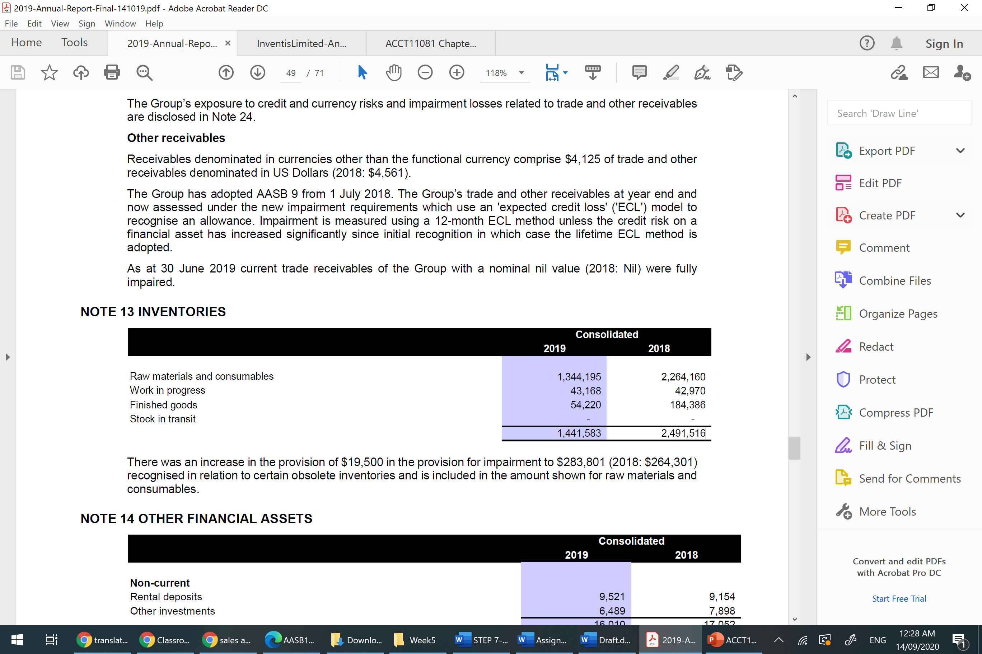

Inventis' inventories have been declining since 2017 when it was at its highest value at $2,566,521. In 2019 inventories valued at $1,441,583, which I think it is still quite a vast amount of money. However, it might be important for a company like Inventis that sells commercial furniture and technology goods and services to have a large inventories figure.
Although the Inventis' annual report has not referred to use any of the recording methods of inventories’ transactions (perpetual or periodic), I would believe that my company uses the perpetual method as it is quite a common method of recording inventories, especially for a large company. So, I would imagine that transactions into and out of inventories are recorded the instant they happen. However, I was wondering does Inventis keep the inventories transactions record separate from their annual report? What if my company was using the periodic method? I understood that if the company use the periodic method, then the transactions into and out of inventories will be periodically recorded.

I could notice that Inventis' inventories police are based on Accounting Standard AASB 102 Inventories as Inventis accounts their inventories according to the lower of cost and net realisable value (NRV). That means Inventis' inventories on the balance sheet are valued at lower of cost or NRV.
NRV is the anticipated selling price in the ordinary course of business minus any associated costs with selling. For example, if Inventis purchased its inventory for $10000 at the beginning of year then at the end of the accounting year, the inventory can be sold for $8,500. The cost Inventis has to incur due to storing, packaging and shipping are $1500. So, to determine the NRV we can use the below formula:
NRV = selling price – cost of sale.
NRV = 8500 -1500= 7000
So, in this case, the Inventis would report its inventory at 7000 on its balance sheet, and it will report a loss of $3000 in its income statement due to write down.

Unfortunately, I do not have any experience with the inventory. The first time I heard about inventory was in my previous unit. All my knowledge is from the study guide and some research on Google to back up my understanding.
Step 8
Last Screenshot of Setup:-
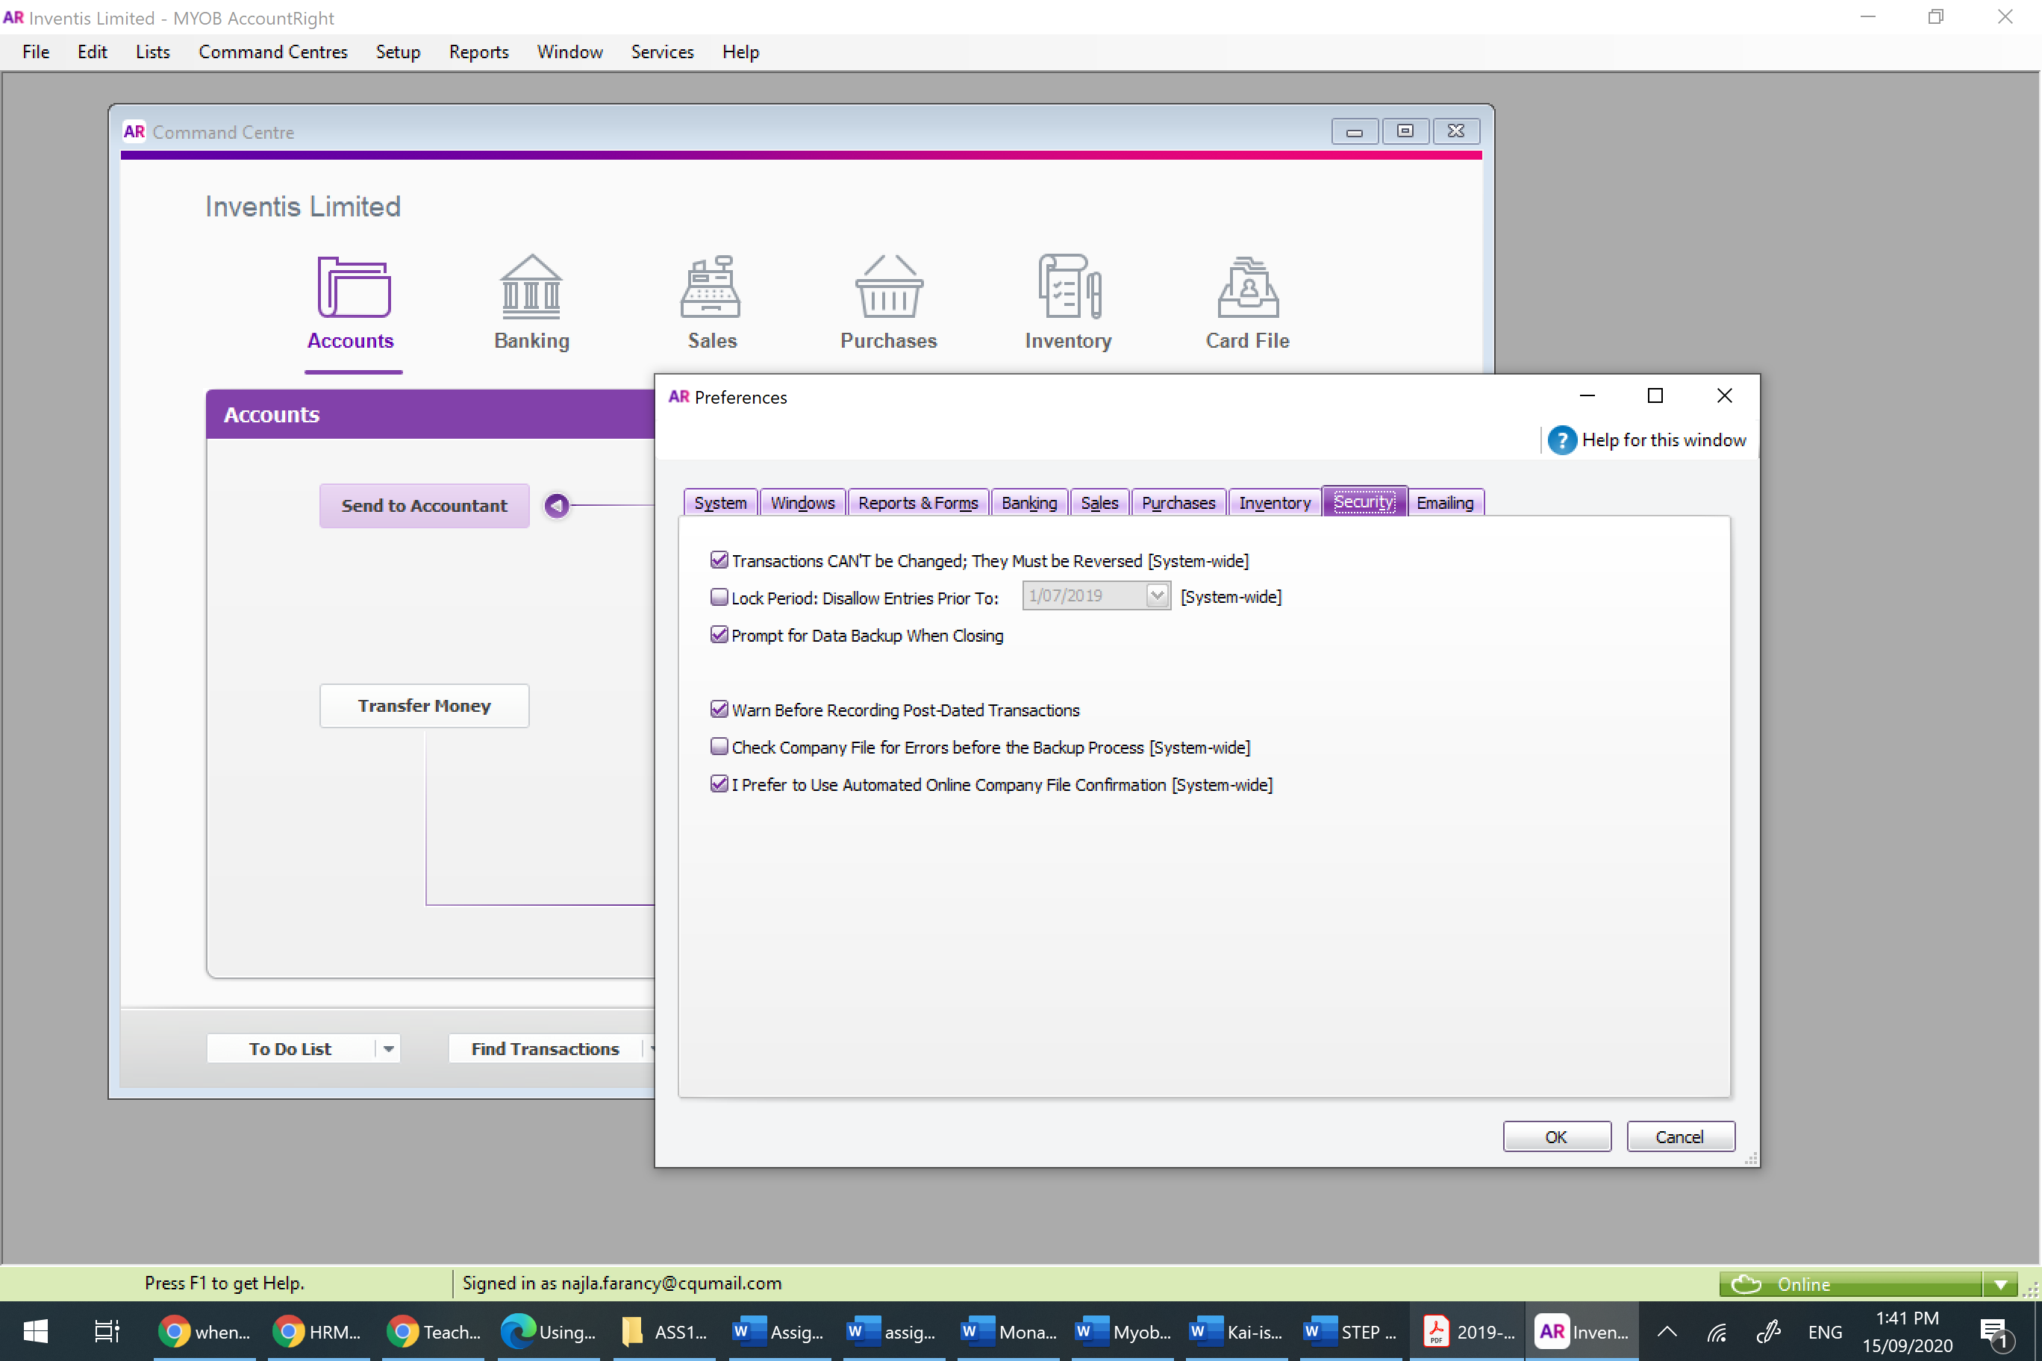

Last screenshot of completing the Training video:-

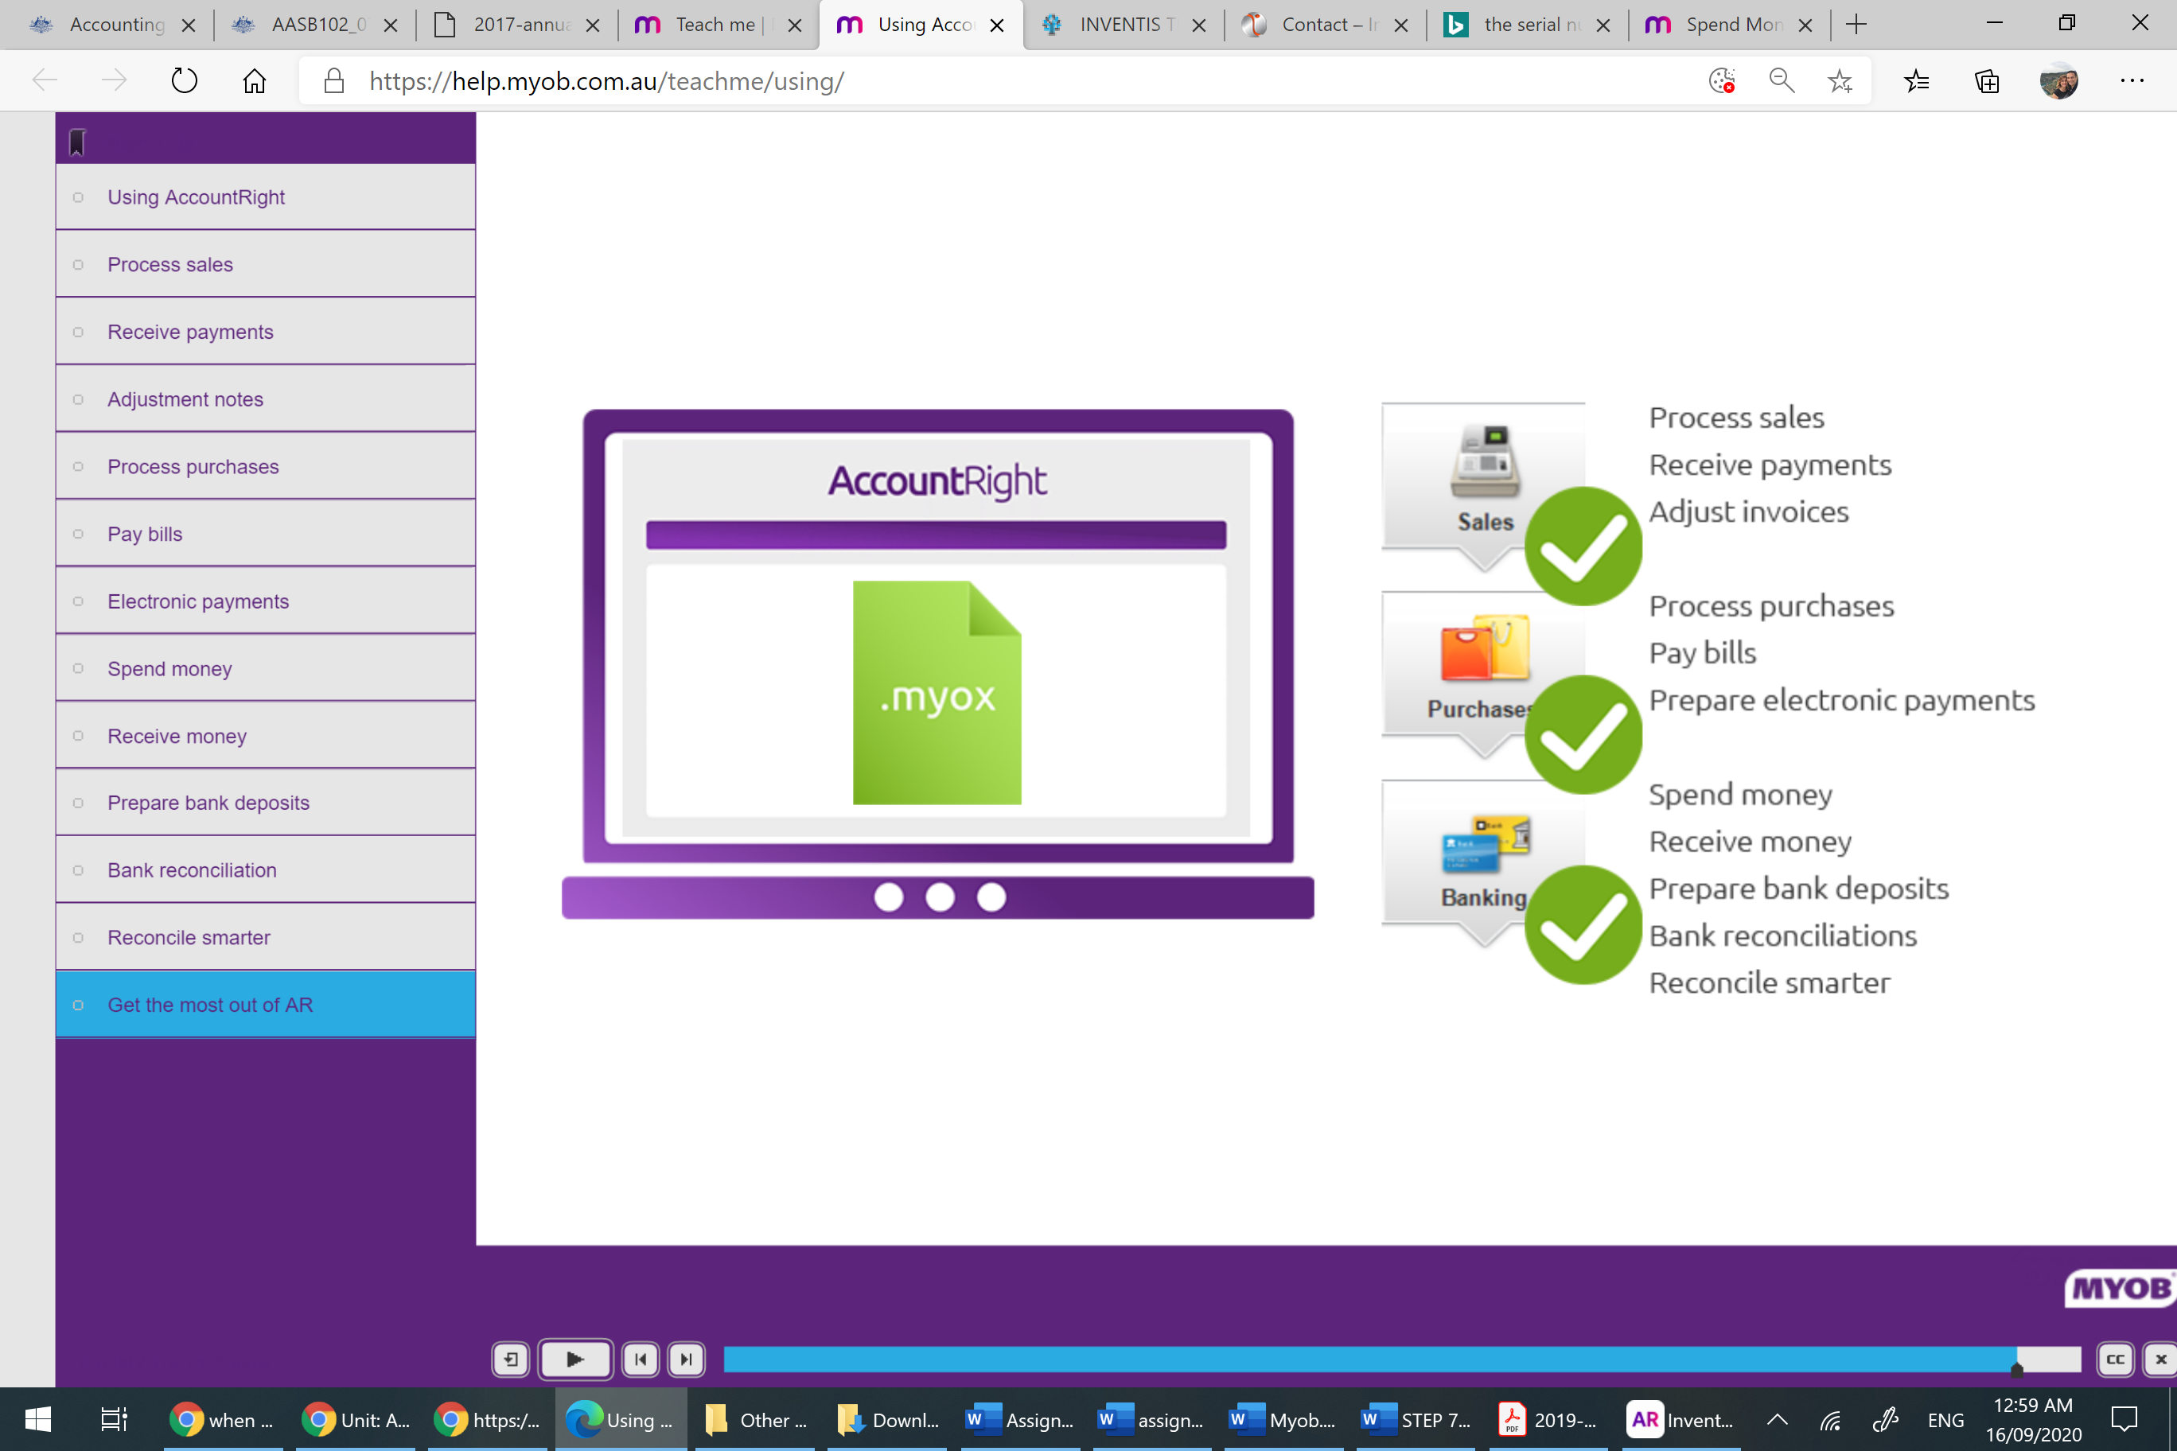

Last screenshot of completing the Training phase:-
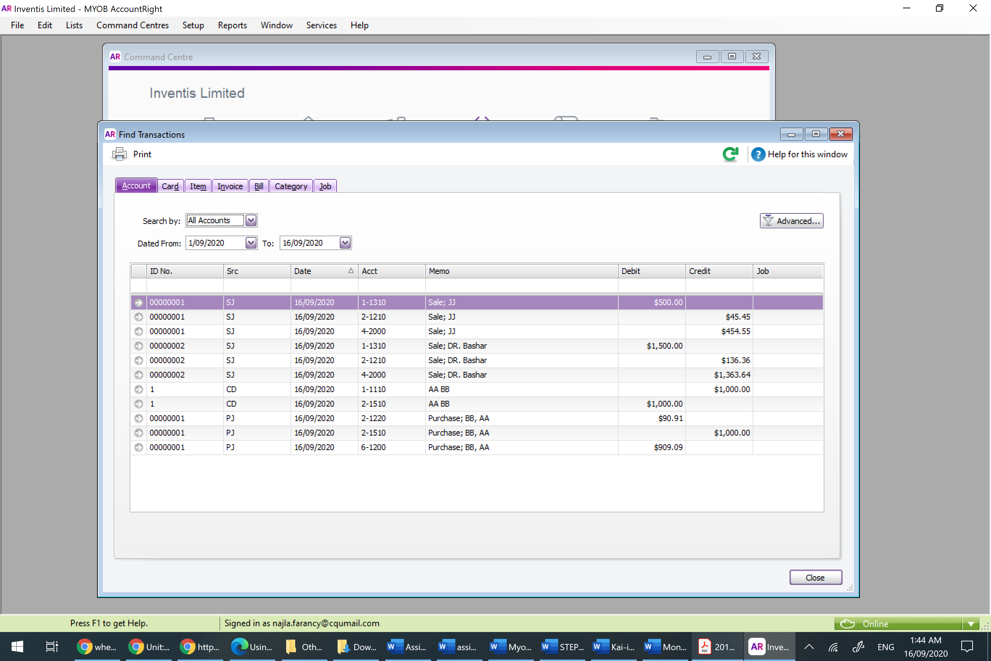
Results:
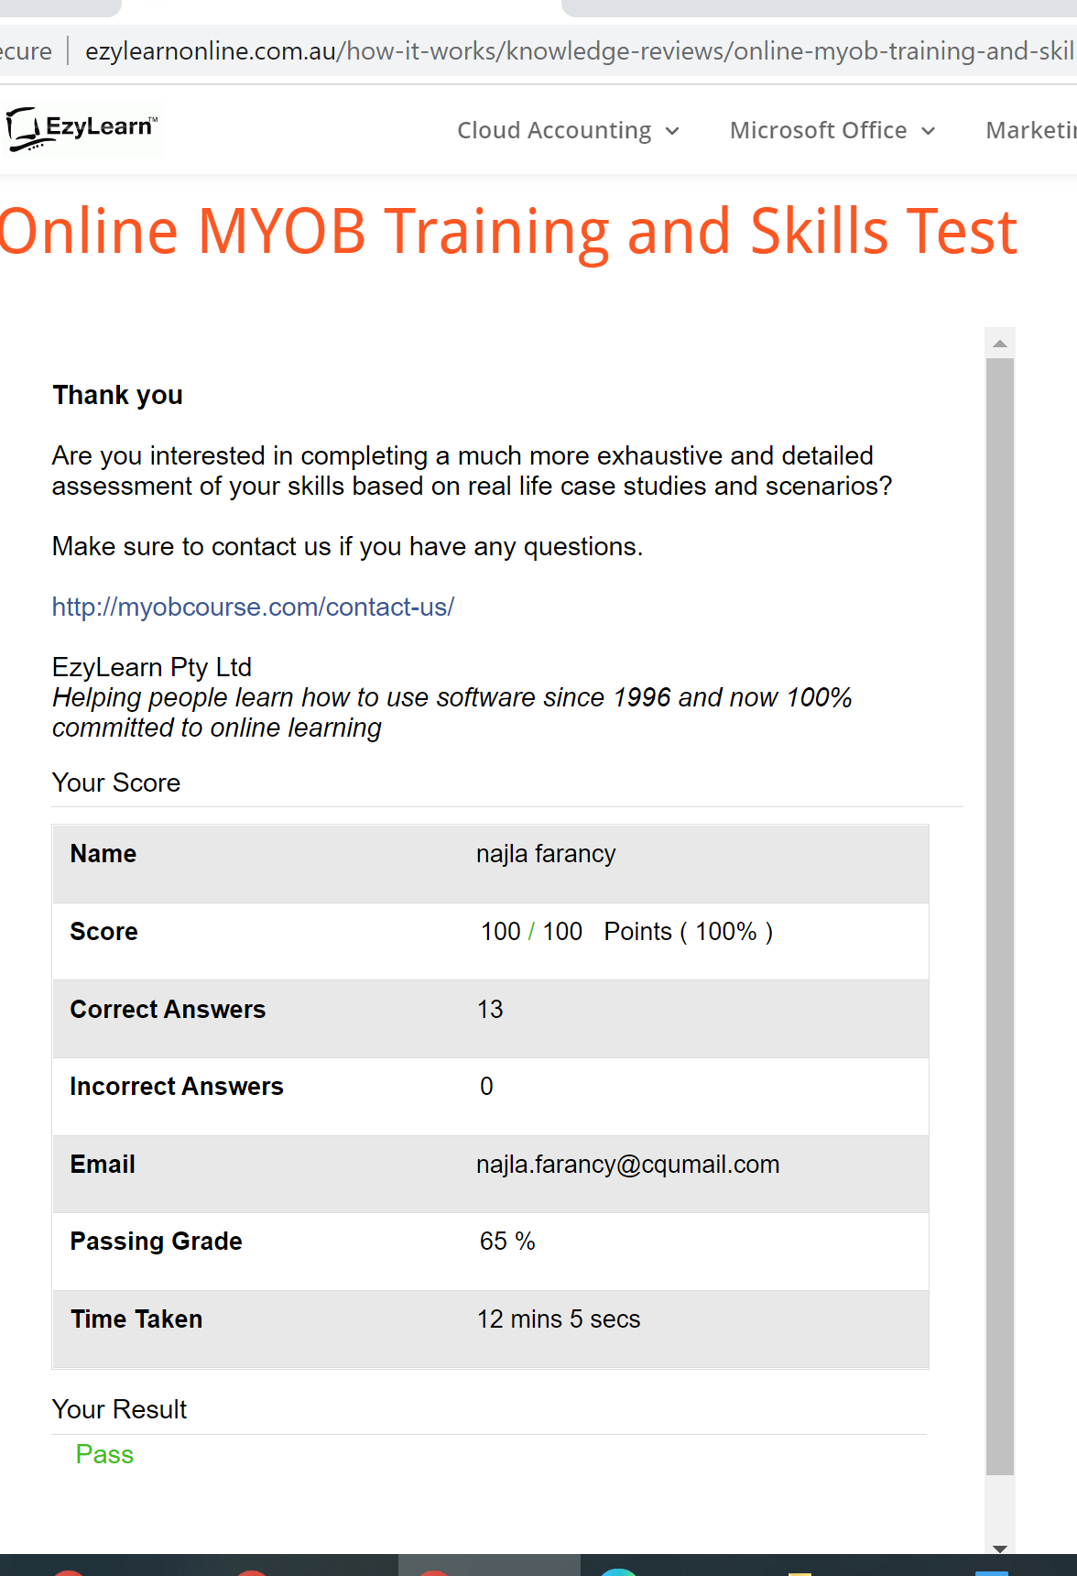

Step-9
Transactions | Date | Amount ($) | Transaction Details
Transaction 1 | 1/07/2020 | $ 50,000 | Invesment by owner - Cash at Bank
Transaction 2 | 3/07/2020 | $ 2,500 | Advertising Expense - Bill paid on 22/9 Using Visa card- Incl GST
Transaction 3 | 7/07/2020 | $ 100,000 | Purchase of Raw Material -Incl GST
Transaction 4 | 11/07/2020 | $ 5,500 | Purchased -Information Technology Services- Incl GST
Transaction 5 | 15/07/2020 | $ 1,000 | Sale - Office Desk- within 90 days- Incl GST
Transaction 6 | 17/07/2020 | $ 7,500 | Sale- Office chair (No. 50 * $150 ) - Within 90 days -Incl GST
Transaction 7 | 23/072020 | $ 1,500 | Electricity Expense - Paid cash- Incl GST
Transaction 8 | 25/072020 | $ 15,000 | Salaries Expense - Paid cash
Transaction 9 | 28/072020 | $ 30,000 | Sales- laptops (No. 15 * $2000)- Within 90 days -Incl GST
Transaction 10 | 30/072020 | $ 4,000 | Rent- Expense - Paid cash- Incl GST

All Journal Report
Inventis Limited
Unit 4, 2 Southridge Street,
Eastern Creek NSW 2766
All Journals
1/07/2020 To 1/10/2020
 |  | ID No. | Account No. | Account Name | Debit | Credit | Job No.
CR | 1/07/2020 | Capital injected by owner
 |  | CR000001 | 3-1000 | Owner's/Shareholder's Capital |  | $50,000.00
 |  | CR000001 | 1-1110 | Inventis Bank Account #1 | $50,000.00
PJ | 3/07/2020 | Purchase; EBN Pty Ltd.
 |  | 00000001 | 2-1510 | Trade Creditors |  | $2,500.00
 |  | 00000001 | 6-1200 | Advertising & Marketing | $2,272.73
 |  | 00000001 | 2-1220 | GST Paid | $227.27
PJ | 7/07/2020 | Purchase; AWZ Pty Ltd.
 |  | 00000002 | 2-1510 | Trade Creditors |  | $100,000.00
 |  | 00000002 | 1-1320 | Inventory | $90,909.09
 |  | 00000002 | 2-1220 | GST Paid | $9,090.91
PJ | 11/07/2020 | Purchase; John Pty Ltd.
 |  | 00000003 | 2-1510 | Trade Creditors |  | $5,500.00
 |  | 00000003 | 6-1600 | Technology Expense | $5,000.00
 |  | 00000003 | 2-1220 | GST Paid | $500.00
SJ | 15/07/2020 | Sale; Dr. Nash Pty Ltd
 |  | 00000007 | 1-1310 | Trade Debtors | $1,000.00
 |  | 00000007 | 4-4000 | Sale of Goods |  | $909.09
 |  | 00000007 | 2-1210 | GST Collected |  | $90.91
SJ | 17/07/2020 | Sale; Dr. Nash Pty Ltd
 |  | 00000008 | 1-1310 | Trade Debtors | $7,500.00
 |  | 00000008 | 4-4000 | Sale of Goods |  | $6,818.18
 |  | 00000008 | 2-1210 | GST Collected |  | $681.82
CD | 23/07/2020 | Ergon Energy
 |  | 7 | 1-1110 | Inventis Bank Account #1 |  | $1,500.00
 |  | 7 | 6-1700 | Electricity Expenses | $1,363.64
 |  | 7 | 2-1220 | GST Paid | $136.36
CD | 25/07/2020 | Employees Payment
 |  | Auto #7 | 6-4100 | Wages & Salaries Expenses | $15,000.00
 |  | Auto #7 | 1-1110 | Inventis Bank Account #1 |  | $15,000.00
SJ | 28/07/2020 | Farancy, Shahla
 |  | 00000009 | 1-1310 | Trade Debtors | $30,000.00
 |  | 00000009 | 4-4000 | Sale of Goods |  | $27,272.73
 |  | 00000009 | 2-1210 | GST Collected |  | $2,727.27
CD | 30/07/2020 | Mr. Smith
 |  | Auto #8 | 1-1110 | Inventis Bank Account #1 |  | $4,000.00
 |  | Auto #8 | 6-2000 | Rent- Expense | $3,636.36
 |  | Auto #8 | 2-1220 | GST Paid | $363.64
CD | 22/09/2020 | EBN Pty Ltd. 3 Eimeo Rd, Rural View QLD 4740 Australia
 |  | 9 | 2-1140 | Visa #2 |  | $2,500.00
 |  | 9 | 2-1510 | Trade Creditors | $2,500.00
 |  |  |  | Grand Total: | $219,500.00 | $219,500.00

Inventis Limited
Unit 4, 2 Southridge Street,
Eastern Creek NSW 2766
Balance Sheet
As of 1/10/2020
Assets
Current Assets
Bank Accounts
Inventis Bank Account #1 | $29,500.00
Total Bank Accounts |  | $29,500.00
Other Current Assets
Trade Debtors | $38,500.00
Inventory | $90,909.09
Total Other Current Assets |  | $129,409.09
Total Current Assets |  |  | $158,909.09
Total Assets |  |  |  | $158,909.09
Liabilities
Current Liabilities
Credit Cards
Visa #2 | $2,500.00
Total Credit Cards |  | $2,500.00
GST Liabilities
GST Collected | $3,500.00
GST Paid | ($10,318.18)
Total GST Liabilities |  | ($6,818.18)
Other Current Liabilities
Trade Creditors | $105,500.00
Total Other Current Liabilities |  | $105,500.00
Total Current Liabilities |  |  | $101,181.82
Total Liabilities |  |  |  | $101,181.82
Net Assets |  |  |  | $57,727.27
Equity
Owner's/Shareholder's Capital |  |  | $50,000.00
Current Year Earnings |  |  | $7,727.27
Total Equity |  |  |  | $57,727.27

Unit 4, 2 Southridge Street,
Eastern Creek NSW 2766
Profit & Loss Statement
1/07/2020 To 1/10/2020
Income
Sale of Goods |  |  | $35,000.00
Total Income |  |  |  | $35,000.00
Total Cost of Sales |  |  |  | $0.00
Gross Profit |  |  |  | $35,000.00
Expenses
Advertising & Marketing |  |  | $2,272.73
Technology Expense |  |  | $5,000.00
Electricity Expenses |  |  | $1,363.64
Rent- Expense |  |  | $3,636.36
Payroll Expenses
Wages & Salaries Expenses |  | $15,000.00
Total Payroll Expenses |  |  | $15,000.00
Total Expenses |  |  |  | $27,272.73
Operating Profit |  |  |  | $7,727.27
Total Other Income |  |  |  | $0.00
Total Other Expenses |  |  |  | $0.00
Net Profit/(Loss) |  |  |  | $7,727.27

Unit 4, 2 Southridge Street,
Eastern Creek NSW 2766
Statement of Cash Flow
1/07/2020 To 1/10/2020
 | Account Name
Cash Flow from Operating Activities
Net Income |  | $7,727.27
 | Trade Debtors | ($38,500.00)
 | Inventory | ($90,909.09)
 | Visa #2 | $2,500.00
 | GST Collected | $3,500.00
 | GST Paid | ($10,318.18)
 | Trade Creditors | $105,500.00
Net Cash Flow from Operating Activities |  |  | -$20,500.00
Cash Flow from Investing Activities
Net Cash Flow from Investing Activities |  |  | $0.00
Cash Flow from Financing Activities
 | Owner's/Shareholder's Capital | $50,000.00
Net Cash Flow from Financing Activities |  |  | $50,000.00
Net Increase/Decrease for the period |  |  | $29,500.00
Cash at the beginning of the period |  |  | $0.00
Cash at the end of the period |  |  | $29,500.00

Initially, I was terrified and stressed using MYOB as it is a new program that I never come across. However, when I commenced watching the tutorials and practice on the company file that was provided by MYOP, things started to become interesting and fun because I could play with number and data entry as I wanted. I admit I made some major mistake, but I gain experience. I created items list that supposed to be for sale purpose, and I thought I could link them with inventory, so I pressed "I inventory this item". Then I used these items in my transactions practice and realised that sales transactions had been recorded in the wrong account. So, I had to fix these items in order to link them to the right account. It took me a bit of time until I could realise that I cannot delete these items because it is the rule of the MYOB program that states items cannot be deleted once they have been used in a transaction. The only option I had was to press “inactive” in order to deactivate these items and to not show them in my future report. This gave me an insight into the sale, sold and inventoried items and how to create each one correctly.
I found that the help centre of MYOB extremely useful as it helped me a lot to learn and fix my mistakes. Also, there is a solution to every single problem with very clear explanation and examples. The most thing I liked in MYOB is the flexibility and efficiency of use. It is a very straightforward program that enables you to change or fix any transaction at any time. I found that changing the date or the payment method, for example, very easy and convenient. MYOB shows an error message with an explanation when the changes are inconsistent with existing data, which is another excellent feature I liked in MYOB.
Overall, through MYOB and entering transactions I could track where each of my transaction was recorded and also, I could better understand the function of each account in my financial statement such as which account include the GST, exclude GST and how the expense and income are calculated and distributed between the financial statements.
Balance Sheet
From my balance sheet, I can notice how most of my transactions have been distributed under the asset accounts, Liability accounts and equity accounts. I could notice how Trade Debtors ( Account receivable) is inclusive the GST as well as for Trade Creditors ( Account payable) that is also inclusive GST, whereas my inventory account was exclusive of GST. Also, I found that my GST paid is greater than GST collected because I have purchased asset valued at $ 100,000, which made up most of my GST paid. My balance sheet tells me that my total asset exceeds my total liability which is in favour of my company. Owner's/Shareholder's Capital shows the amount of money that was invested by the owner into the company. The balance sheet also shows the net income for the year, which is $7,727.27.
Income Statement
It was very interesting to see how all the sales and expenses are exclusive of GST in the income statement. Although we have been studying this the whole term and Martin were always trying to remind us about how income statement and balance sheet are exclusive of GST except for Account receivable and account payable that are inclusive of GST, examining this data in practice helped in engraving this information in my mind. I also found that all my incomes and expenses are listed in the income statement. Honestly, at first, I was not sure if the cash payment would be included in the income statement, but I found it was listed there so that helped me to eliminate my doubt and to learns that all type of expenses would be recorded in the income statement.
Statement of Cash Flow
My company's operating activities comprise of Trade Debtors, Inventory, Visa #2 GST Collected GST Paid Trade Creditors accounts. Net Cash Flow from Operating Activities It was interesting to see all these accounts have been included in cash flow sta -$20,500.00
It is obvious that my company did not has any investing activities as there was no transaction for purchasing fixed assets such as property, plant and equipment or intangible assets such as Patents and trademarks, customer relationships etc. In respect to financing activities, the only activity was the money injected by the owner into the company account. So, my Net (decrease) / increase in cash is $29500 and cash at the end of the period is $29,500.00 because I did not have cash at the beginning of the period to sum it with. I used the below formula just to make sure that my result is the same as in MYOP report statement
Net (decrease) / increase in cash = Net cash from/used in operating activities + Net cash from/used in financing activities + Net cash from/used in investing activities
-$20,500.00 +$50,000.00 +$0.00 = $29500 (Net (decrease) / increase in cash),

Also, to calculate cash at the end of the period, I used the below formula

Cash at the end of the period= Cash at the beginning + Net Increase/Decrease for the period
$0.00 + $29,500.00= $29,500.00 ( Cash at the End of the period)
Although my transactions are hypothetical, my company's financial statement can tell me that my company is doing very well because it has cash and it is making profit throughout its activities.
Step 10
Property, plant and equipment (PPE) is the second-largest non- current asset in my company's balance sheet, which is the tangible non-current asset for my company. In other words, they are physically existing. PPE comprises of leasehold improvements, furniture and fittings, plant and equipment and motor vehicles. During the last four years, my company's PPE has declined gradually. In 2019 it was at its least amount. I think this decline in PPE amount was attributed to reducing the purchases of PPE in 2018 and 2019.
Property, Plant & Equipment
Balance at 30 June
 | 2019 | 2018 | 2017 | 2016
Leasehold improvements | $ 42,165 | $ 61,747 | $ 85,622 | $ 109,497
Furniture and fittings, | $ 8,112 | $ 9,708 | $ 18,054 | $ 20,420
Plant and equipment | $ 103,496 | $ 144,510 | $ 201,735 | $ 243,733
Motor vehicles | $ 16,501 | $ 18,385 | $ 20,511 | $ 20,535
Total | $ 170,274 | $ 234,350 | $ 325,922 | $ 394,185

According to AASB 116 para 16, items in PPE should be initially recorded at its cost and this cost should include purchases price, the cost for being capable of operating and an estimate of the costs of restoring the site in future. I believe that my company followed the accounting standard of recording property, plant and equipment items by including all the costs associated with this asset. Note 3 in my annual report state:-
Cost includes expenditure that is directly attributable to the acquisition of the asset. The cost of self-constructed
assets includes the cost of materials and direct labour, any other costs directly attributable to bringing the assets
to a working condition for their intended use, the costs of dismantling and removing the items and restoring the
site on which they are located."
I noticed that my company for the last four years measures its property, plant and equipment classes based on the cost model because it uses the cost less any accumulated depreciation. This is also has been stated in their policies. In other words, the carrying amount of property, plant and equipment classes valued at the price spent to acquire. I was wondering does this model provides an accurate worth of a non-current asset because the price of the assets can dynamically change. The below tables are what my company disclosed in its footnote 15 and 16 about its property, plant and equipment that show my company depreciated its items of property, plant and equipment.
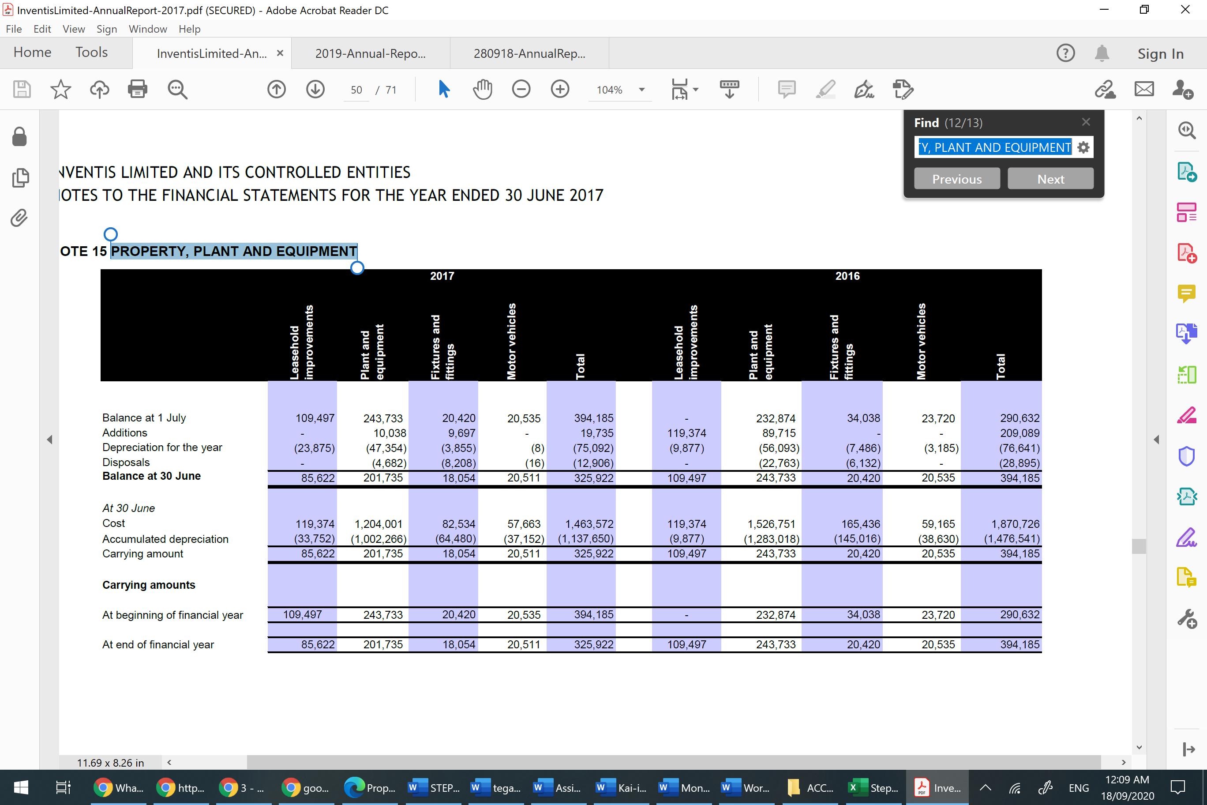
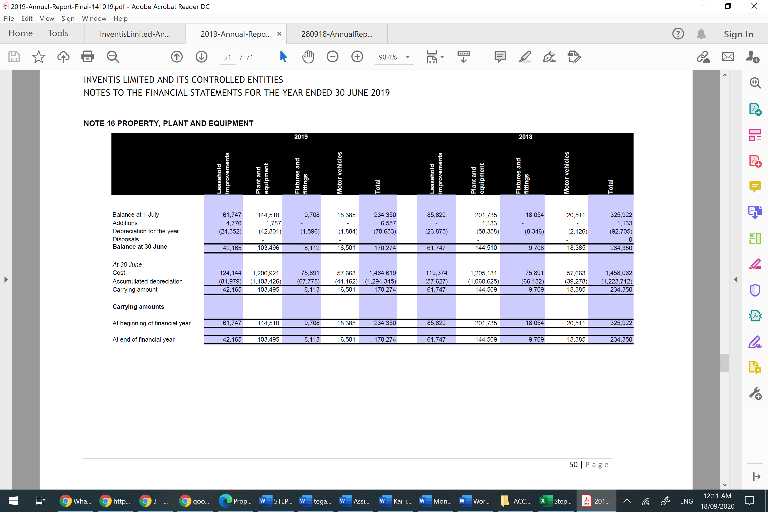
Moreover, in the last two years, my company did not record any disposal item in its property, plant and equipment. I would think this can be because of its item of property, plant and equipment is still generating economic benefit for Inventis. However, in 2017 and 2016 Inventis had recorded a loss on disposal on its items of property, plant and equipment. Thorough the footnote 7, I could find that Inventis included the losses from the disposal of property, plant and equipment under "other income" account in its income statement.
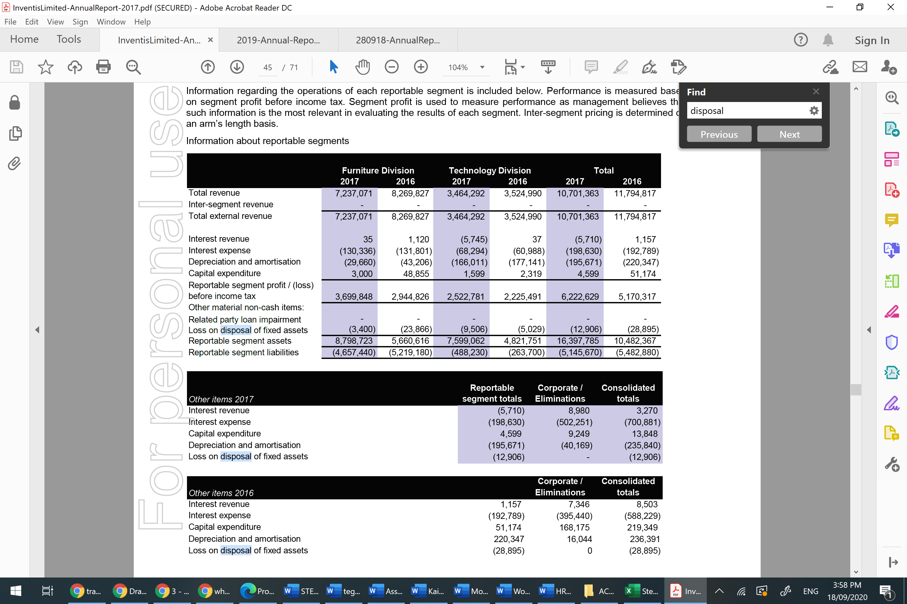
My company's policies about depreciation are that "depreciation is calculated over the depreciable amount, which is the cost of an asset, or other amount substituted for cost, less its residual value". Prior to 2008, my company used to use diminishing value. However, since 2008 straight-line basis is the method my company uses to calculate depreciation for its assets. In other words, my company assigns an equal amount of depreciation for its items of property, plant and equipment each year as long they are still in service. This is what my company disclosed about the depreciation rates calculated under the straight-line method:
Leasehold improvements 2.5% SL
Plant and equipment 9% - 50% SL
Furniture and fittings 11.25% - 40% SL
Motor vehicles 22.5% SL
Leased plant and equipment 20% - 33% SL
Inventis' depreciation policies have been the same for the last four years. Inventis did not disclose an estimate of useful life in years for property, plant and equipment items. Also, I could find any expense relate to depreciation and amortisation in my income statement.
Intangible assets are the most considerable non-current assets in my company's balance sheet. They comprise of goodwill, patents and trademarks customer relationships and development cost. These assets neither can be seen nor touched. Goodwill made up most of my company's intangible assets though it has slightly declined since 2016. It appears that may company has acquired a good business reputation that can support long-term success.
intangible asset
Balance at 30 June
 | 2019 | 2018 | 2017 | 2016
Goodwill | $ 2,973,867 | $ 2,973,867 | $ 3,060,934 | $ 3,060,934
Patents and trademarks | $ 55,000 | $ 55,000 | $ 55,000 | $ 55,000
Customer relationships | $ - | $ - | $ - | $ -
Development cost | $ 13,016 | $ 323,943 | $ 484,724 | $ 642,472
Total | $ 3,041,883 | $ 3,352,810 | $ 3,600,658 | $ 3,758,406

Other financial assets are the last item in my non-current asset, and they include Rental deposits and Other investment.
Other Financial Assets
Balance at 30 June
 | 2019 | 2018 | 2017 | 2016
Rental deposits | $ 9,521 | $ 9,154 | $ 8,800 | $ 6,136
Other investments | $ 6,489 | $ 7,898 | $ 6,285 | $ 5,451
Total | $ 16,010 | $ 17,052 | $ 15,085 | $ 11,587

When I read in chapter 5 that depreciation represents our estimate of the reduction in the market value of property, plant and equipment. This was exactly my initial thought about depreciation. Throughout the reading and watching the videos I realised that depreciation is the method of estimating the using up of an item of property, plant and equipment (fixed asset) with the benefit gained over its useful life. In other words, is how much we can expect to gain benefit from our asset before it becomes usefulness? It was interesting to learn that the asset turns into expense through the process of depreciation. Since fixed assets are usually expensive and last for years, their costs should be written off over a period of time and that what depreciation does. Without depreciation process, a company might overstate the value of its fixed assets that also leads to overstating its profit due to the absence of expense associated with these assets. The overstated profit results in higher tax liability, which means incur losses. I could understand now why depreciation is a necessary expense in our firm's income statement because the firm can use this expense for a tax deduction and reduce its tax liability. Therefore, depreciating the assets over a period of time can give a company an accurate value of its asset and expense incurred because assets lose their value after using over a number of years.
I tried to find how much depreciation expense my company has in its income statement. Unfortunately, I could not find any helpful information to see where this expense is linked because I know I have property, plant and equipment items that my company depreciate their cost. So, I would expect there should be some depreciation expense linked in my income statement. I was wondering if I am missing something or did my company not provide enough information to track these expenses?

It was also interesting to learn that useful life of an asset in business would mean how many years we want to keep this asset to generate revenue over that period. For example, if Inventis depreciate its motor vehicle for three years, that would mean that Inventis is planning to employ this asset for only three years, which is the useful life of the motor vehicle for Inventis. However, it does not mean that the effective life of the motor vehicle is over cannot be used or it is out of life. It just how Inventis estimate the usefulness of this asset for the company's revenue.

Understanding the concept of depreciation was not easy; however, the concept of depreciation was very interesting. I always thought it is about reducing the value of an asset that is not in favour of a business. I was wrong from the accounting perspective because depreciation concept is about expensing the asset cost over its useful life for the business. The process of depreciation help businesses to have an accurate picture of their profit and loss via the principle matching of revenue with the expense.

Three Journal Entries for depreciation:
We need to debit our depreciation expense in our income statement and credited our accumulated depreciation until the asset is disposed of in our balance sheet.
Date | Journal Entry $ | Debit | Credit
30 June 2019 | Depreciation expense – Furniture and fittings  Accumulated Depreciation- Furniture and fittings  (Depreciation expense for the year) | 1,596 | 1,596

Date | Journal Entry $ | Debit | Credit
30 June 2019 | Depreciation expense – Motor Vehicles  Accumulated Depreciation- Motor Vehicles  (Depreciation expense for the year) | 1,884 | 1,884

Date | Journal Entry $ | Debit | Credit
30 June 2019 | Depreciation expense – plant and equipment  Accumulated depreciation- plant and equipment  (Depreciation expense for the year) | 42,801 | 42,801

What effects do these journal entries have on your firms' financial statements?
Income Statement:-
Fixed assets that turn into expense using the depreciation method will be debited as an expense under depreciation expense account ( because an increase in expense is a debit ). Although depreciation expense reduces the company's earning, it can be helpful to reduce tax liability.
Balance Sheet:-
Based on the double-entry accounting for every debit side, there will be a credit side. So, the credit side of depreciation expense is the accumulated depreciation account. So, when depreciating an asset over multiple years would mean decrease in an asset over a period of time and will be credited and recorded under accumulated depreciation account ( because a decrease in an asset is credit).
In response to the question Are there any areas where it might be possible to manipulate these entries? I would say yes very likely as a business can decide on the asset's useful life some can go for a short time, and other might go for a long time whatever is in the best of interest of a business. Also, because depreciation is based on assumptions and judgements, so there is no transaction or cash changing hands involving in recording it, which can be easily manipulated.

